

**Operational Handbook**

**Stellaris Ticket Creation**

**Version – 1.0**

This documentation is the property of Novatio and may contain confidential or privileged information. Unauthorized use of this documentation is strictly prohibited and may be unlawful. The information within may not be disclosed to a third party without the written consent of an authorized representative. No part of this document may be reproduced or transmitted in any form or by any means, electronic or mechanical, including photocopying without the written permission of Novatio.

© Novatiosolutions.com

All trademarks are hereby acknowledged and are used to the benefit of their respective owners.

**DOCUMENT VERSION CONTROL**

|  |  |  |  |
| --- | --- | --- | --- |
| Date Issued | Version | Description | Author |
| **5/30/2019** | **1.0** | **Operational Handbook** | **RPA COE Team** |

Table of Contents

1. Introduction to build 5

1.1 Document Reference 5

2. Operational Details 5

2.1 Application Details 5

2.2 Process/Workflow Details 5

2.3 Robot Details 6

3. Exception Details 6

3.1 Business Exception 6

3.2Application Exception 7

4. Data Storage 9

4.1 Logs 9

4.2Custom Log fields 9

5. Assets 10

6. Input/output file storage: 10

7. Folder Structure 10

8. Kibana - Reports 11

9. BOT Schedule 11

# 1. Introduction to build

This document is intended for the client’s project delivery team to ensure that all components of the required operational architecture are in place to be used by the support team.

## **1.1 Document Reference**

|  |  |  |
| --- | --- | --- |
| **Reference document** | **File Name** | **Link to access process definition and solution design document** |
| Process definition document | Stellaris Pdd.doc | <Github> |
| Solution design document | Stellaris Sdd.doc | <Github> |

# 2. Operational Details

Bot will look for the emails which comes from the four hospital to stellaris serviceDesk.(Input)

Bot will collect the required information to create the ticket from email.

Bot will login into Opas Desktop Application Submits the ticket and capture the ticket number and reply to the same email with ticket number in the subject line and body of the email with today’s date. (output)

Bot will move the email to complete folder and share drive.

## **2.1 Application Details**

List the applications involved in the process and its type.

|  |  |  |
| --- | --- | --- |
| **Application Name** | **Description** | **Type of application** |
| Opas Remedy Tool | Access Sd Control Queue To Create Request | Desktop-based |
| Outlook | Access the Stellaris Service Desk Email To Create Tickets for Four Hospitals | Desktop-based |

## **2.2 Process/Workflow Details**

|  |  |
| --- | --- |
| Process/package Name | Rit-101 Stellaris Nttdata |
| Package version Used | <enter the package version that is live> |
| Environment Mapped to | ops |
| GitLab repository URL of the workflow file |  |

## **2.3 Robot Details**

|  |  |
| --- | --- |
| Number of BOTs executing the process | Only one bot for now |
| Name of the BOTs | 101-Stellaris |
| Windows Logon ID used by BOT | Kamal’s Login Id |
| Mail ID used by BOT | Kamal’s Email Id |

# 3. Exception Details

## **3.1 Business Exception**

# Describes an error rooted in the fact that certain data which the automation project depends on is incomplete or missing or application is not responding will be handled by the Business unit

|  |  |  |
| --- | --- | --- |
| **List of Business Exceptions** | **Action Needed by support team** | **Action to be taken** |
| Application Downtime/server issue/bad credentials | Yes | Disable the process schedule until the issue is fixed/credentials reset after obtaining approval from business |
| Unable to find the account details for the respective account number | No | BOT moves the order to the BOT fallout queue-To be worked by the business team |
| Change in User interface /page layouts | Yes | Disable the process schedule until the issue is fixed/credentials reset after obtaining approval from business |

Notification should be sent to below contacts for all the above exceptions:

|  |  |  |
| --- | --- | --- |
| **Contact details** | **Name** | **Email Address** |
| Business contacts | Cynthia,Wilkinson | Cynthia.Wilkinson@nttdata.com |
| Support Team to be copied | Venkatesh,Singamsitty  Srinivas, encherla | [Venkatesh@novatiosolutions.com](mailto:Venkatesh@novatiosolutions.com)  srinivas@novatiosolutions.com |

**3.1.1 Escalation Contact for Business**

* Kamal,K - kamal.k@nttdata.com

**3.1.2 Sample notification mail for Business Exception**

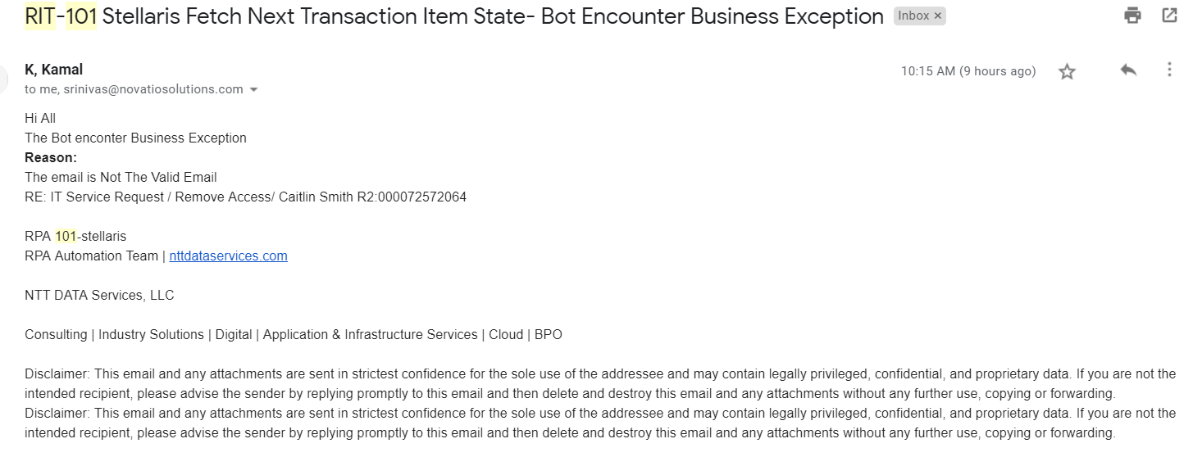

## **3.2 Application Exception**

# Breaks the normal flow of execution and executes a preregistered exception handler which will be handled by the support team.

**For example,**

* Select Activity Fails
* Click activity Fails
* Type into activity Fails

Notification should be sent to below contacts for all the above exceptions to fix it:

|  |  |  |
| --- | --- | --- |
| **Contact details** | **Name** | **Email Address** |
| Development Team contacts | Venkatesh,singamsitty | venkatesh@novatiosoluions.com |
| Support Team to be copied | Srinivas,encherla | srinivas@novatiosolutions.com |

Development Team Escalation contact

1. Srinivas Encherla **-** srinivas@novatiosolutions.com

Sample notification mail for Application Exception:

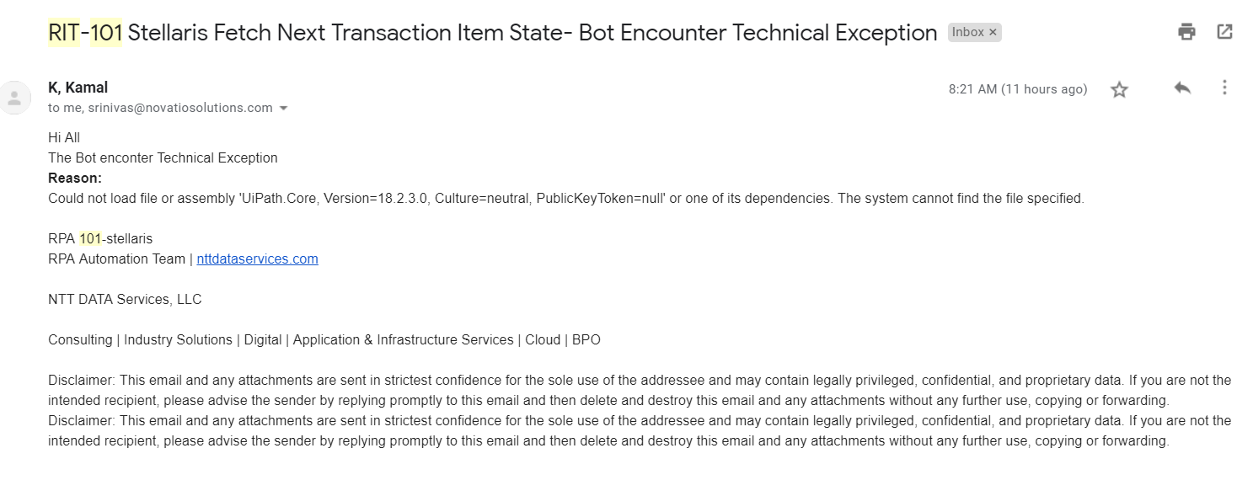

Data Storage

# Logs

All the logs from the robot will be stored in the Orchestrator, log file in the BOT VM and in the SQL server given below:

* + 1. SQL Database name - Uipath
    2. Server/DB Instance =

# Assets

Below are the details of the assets stored in Orchestrator related to this process:

|  |  |  |
| --- | --- | --- |
| **Asset Name** | **Description** | **Type** |
| Rit-101EmailLogin | To Send Exceptional Email | Credentials |
| Rit-101OpasLogin | Remedy Ticket Tool | credential |
| Rit-101OpasFilePath | Application File Path | String |
| Rit-101ServiceDeskEmail | Stellaris Service Desk Email | String |

Below is the point of contact in case the asset/credentials need to be updated,

|  |  |  |
| --- | --- | --- |
| **Contact details** | **Name** | **Email Address** |
| Development Team contacts | Venkatesh,Singamsitty | venkatesh@novatiosolutions.com |
| Support Team to be copied | Srinivas,Encherla | srinivas@novatiosolutions.com |

# Input/output file storage:

Below are the details of the location in which the input/output files stored/downloaded in this process will be stored in the BOT VM/Shared drive.

* Kamal Desktop and Github

# Folder Structure

Below is the folder structure of Project source code- This Process doesn’t have any folder structure.

|  |  |  |
| --- | --- | --- |
| Folder Structure | | Description |
| Main Folder Name | Subfolder 1 | Not applicable |
| Main Folder Name | Subfolder 1 | Not applicable |

# User - Reports

We are creating Excel Report of total tickets created successfully and tickets failed to create by Business exception or Technical Exceptions

# BOT Schedule

Below are the scheduling details of the process:

|  |  |
| --- | --- |
| Type of Schedule | On-Demand |
| Timing | Morning 7am est to Evening 10pm est |
| Holiday’s to be taken into account | New Year’s Day              Jan 1  Memorial Day                 May 28  Independence Day         July 4  Labor Day                       September 3  Thanksgiving Day          November 22  Designated Day             November 23  Christmas Eve                December 24  Christmas Day               December 25  <Change this section as required> |
| Outage/ Maintenance Window for BOT VM | Support Team will notify BU if there are any maintenance issue with VM |
| Outage/Maintenance window for applications involved | BU to inform support team if there are any maintenance of the application involved |

--End of the document--